|  |  |  |  |
| --- | --- | --- | --- |
| **PROTOCOL**  For lab-exercise  **Current Source** | | |  |
|  | | | |
| Group / Class | Script writer | Signature: | |
| 3/4 / 4AHELS | Unger Ulrich |  | |
| Date of exercise / Hand-in date | Team member | Signature: | |
| 19.05.2015  02.06.2015 | Spannagl Roland |  | |
| Teacher | Team member | Signature: | |
| TILL | Fock Daniel |  | |
| Grade | Team member | Signature: | |
|  |  |  | |
| **NPN Transistor** | | | |
| VERWENDETE GERÄTE:   |  |  |  |  | | --- | --- | --- | --- | | Number | Device | Company | Type | | 1 | Power Supply | EMG | 18135 | | 2 | Multimeter | TE.Electronic | VA 18B | | | | |

# 

Task:

It was to build and calculate some circuits for current sources measurements with the following setting:

IC = 2 mA

Simple one:

Circuit:

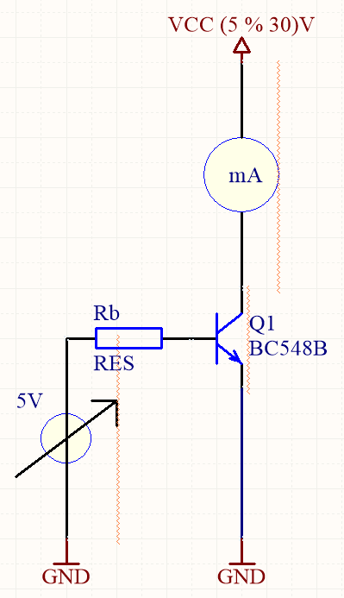

Fig. 1: simple one circuit

Calculations:

RB =



Measurement:

|  |  |
| --- | --- |
| Vcc [V] | Isource [mA] |
| 5 | 1,99 |
| 7 | 2,01 |
| 9 | 2,03 |
| 11 | 2,06 |
| 13 | 2,08 |
| 15 | 2,11 |
| 17 | 2,13 |
| 19 | 2,16 |
| 21 | 2,19 |
| 23 | 2,21 |
| 25 | 2,25 |
| 27 | 2,28 |
| 29 | 2,31 |
| 30 | 2,34 |

Table 1: simple one

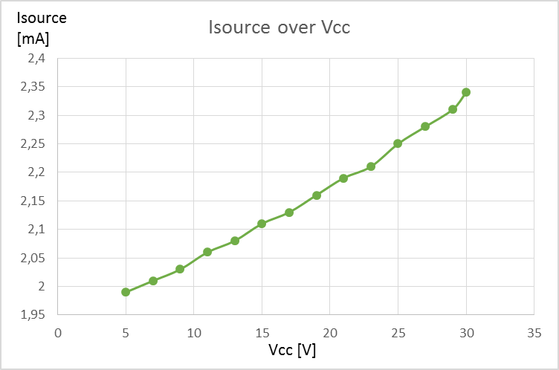

Fig. 2: diagramm ΔUa

Improved Current Source:

Circuit:

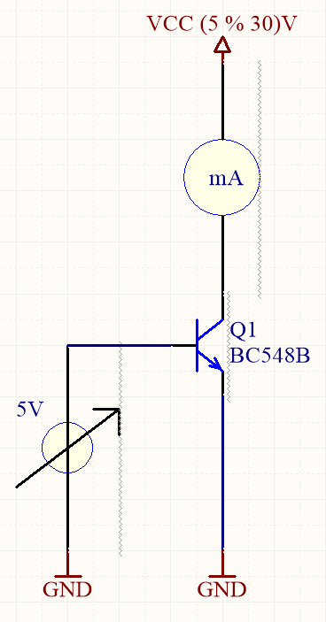

Fig. 3: circuit for improved current source

Calculations:

RE =



Measurement:

|  |  |
| --- | --- |
| Vcc [V] | Isource [mA] |
| 5 | 2,026 |
| 10 | 2,028 |
| 15 | 2,03 |
| 20 | 2,033 |
| 25 | 2,036 |
| 30 | 2,038 |

Table 2: improved current source

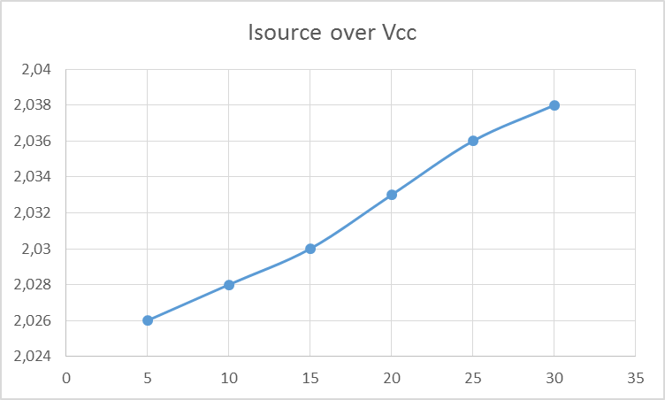

Fig. 4: diagram improved current source

Two Transistor Current Source:

Cicuit:

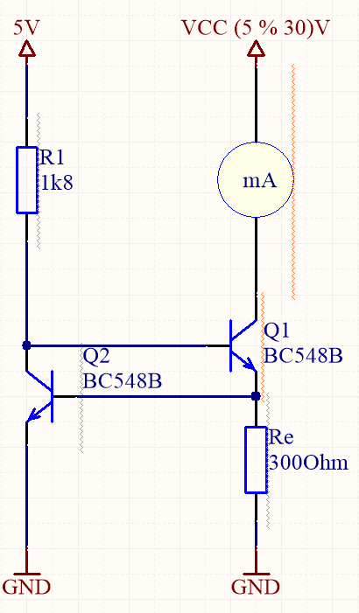

Fig. 5: two transistor current source circuit

Calculations:

R1 = = 2k2Ω



RE =



Measurement:

|  |  |
| --- | --- |
| Vcc [V] | Isource [mA] |
| 5 | 1,966 |
| 10 | 1,966 |
| 15 | 1,967 |
| 20 | 1,967 |
| 25 | 1,967 |
| 30 | 1,967 |

Table 3: two transistor current source

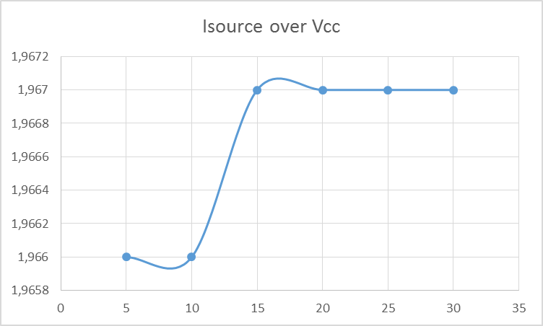

Fig. 6: diagram two transistor current source

10:1 Current Mirror:

Circuit:

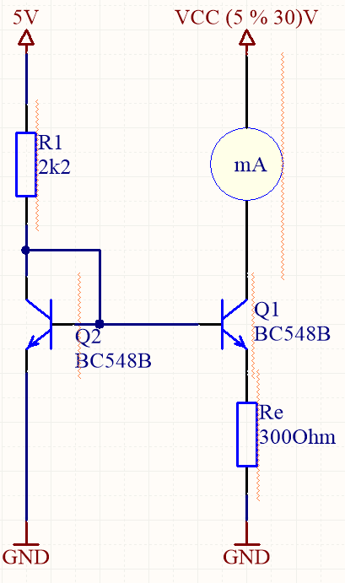

Fig. 7: circuit for 10:1 current mirror

Calculations:

R1 = = 2k2Ω



RE =



Measurement:

|  |  |
| --- | --- |
| Vcc [V] | Isource [mA] |
| 5 | 0,1775 |
| 10 | 0,1788 |
| 15 | 0,1799 |
| 20 | 0,1811 |
| 25 | 0,1825 |
| 30 | 0,1838 |

Table 4: 10:1 current mirror

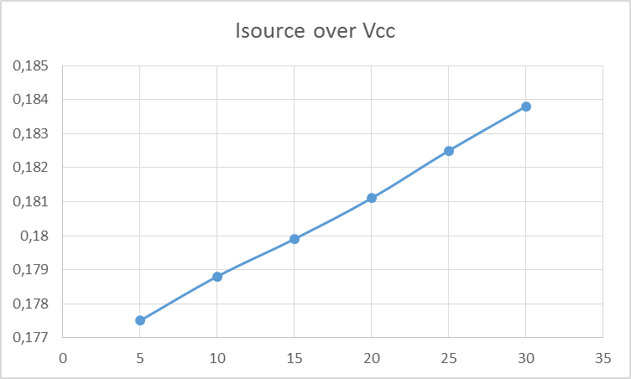

Fig. 8: 10:1 current mirror

Improved Current Mirror:

Circuit:

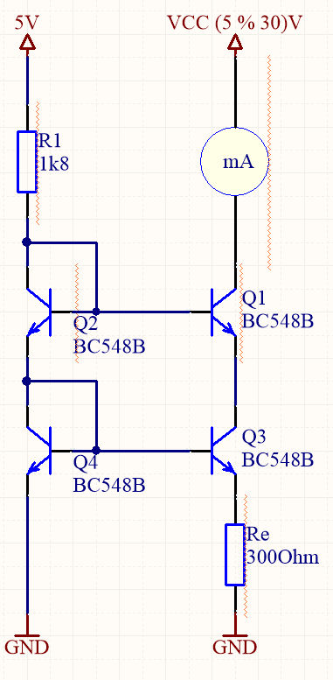

Fig. 9: cicuit for improved current mirror

Calculations:

R1 = = 2k2Ω



RE =



Measurements:

|  |  |
| --- | --- |
| Vcc [V] | Isource [mA] |
| 5 | 0,1456 |
| 10 | 0,1455 |
| 15 | 0,1455 |
| 20 | 0,1455 |
| 25 | 0,1455 |
| 30 | 0,1455 |

Table 5: improved current mirror

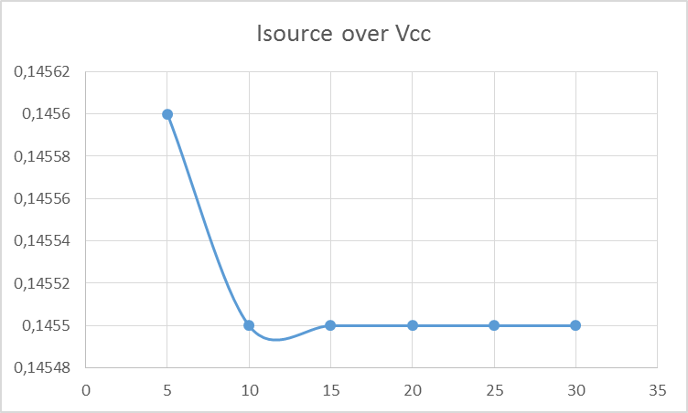

Fig. 10: diagram of improved current mirror